**MONITORING DRIVER’S LETHARGY FOR CAR SAFETY**

|  |  |  |
| --- | --- | --- |
| Dr. S.Ram SubbaReddy  Associate Professor  Information Technology  VNR VJIET | K. Gowri Nandini  B-Tech Graduate  Information Technology  VNR VJIET | K. Yutika  B-Tech Graduate  Information Technology  VNR VJIET |
| Teekshala.K  B-Tech Graduate  Information Technology  VNR VJIET | T.Harika  B-Tech Graduate  Information Technology  VNR VJIET |  |

**ABSTRACT**

In the study which is being presented, driver drowsiness is done automatically. Road accidents may be decreased if the driver is warned when he is driving while weary. The auto camera is used to detect drowsiness in this example, and a neural network assesses whether the driver is conscious or sleepy relying on the image it captures. The convolutional neural network (CNN) technology has been exploited as a part of a neural network, where each frame is judged separately and the average of the previous 20 frames, which equates to roughly one second in the training and test dataset, is evaluated. In order to create a framework based on convolutional neural networks, we first investigate picture feature extraction. We train and evaluate the segmentation network to extract the driver's emotional status from the photos using an annotated dataset of more than 2000 image slices.

**Keywords: -** CNN, Eye Closed & Open dataset, no_yawn & yawn dataset, drowsiness

# **INTRODUCTION**

To prevent traffic accidents in this generation, it is crucial to recognize or monitor driver fatigue. There seems to be a chance that a road accident will occur while driving a truck for a prolonged period of time over a long distance, as well as while driving a bus or cab at night or on drowsy days. That often, this happens on highways where people or drivers want to drive quickly on an empty stretch of highway. The conventional policies are unable to identify driver drowsiness based on the movement of the vehicle and the physiological state of the driver. So that driver drowsiness might be accurately and cheaply identified without the use of expensive techniques. Image processing approaches are referred to as "drowsy detection" based on the study of numerous research articles. This method is more cost-effective and simple since it eliminates the need to buy overpriced sensors and eliminates the reliance on driver physiological state and vehicle movement. The mouth, eyes, and nose are the primary facial feature sites used to detect tiredness while driving. Several approaches are available for human face detection in image processing techniques. So, I had finally decided to create a driver drowsiness monitoring system using ML classification techniques and image processing techniques. We provided our suggested system architecture. This design process is informative of things like First, a web camera will be activated, and after a few period of time, it will be able to collect frames and turn those frames into a two-dimensional image. Later, using the same image, this system will be able to recognise faces. Following that, it will identify facial landmarks like the eyes, mouth, and nose from the face-detected image. In order to determine the threshold values, the eye aspect ratio (EAR), mouth opening ratio (MOR), and nose length ratio (NLR) are calculated. The driver will receive a drowsy alert if any of these three threshold readings exceeds the predefined criterion after being compared with adaptive input parameters.

**RELATED WORK**

**Existing System**

In the current system, the driver drowsiness detection system uses eye blinking to prevent accidents brought on by unconsciousness. Here, a single eye blink sensor is fixed in the car, and if the driver passes out, it informs them through buzzer to avoid an accident. In the future, we can install drowsiness detection systems in aircraft to warn.

**Proposed System**

With a number of technological solutions that can prevent this disaster, automotive researchers and manufacturers are attempting to control the issue. This article focuses on methods based on neural networks for the detection of such micro sleep and sleepiness. In earlier research, the same was detected utilizing machine learning and multi-layer perceptron. In this study, accuracy was improved by using facial cues that the camera picks up, which are then fed to a CNN to classify drowsiness into four categories: closed, open, no yawn and yawn.

Dataset-

<https://www.kaggle.com/dheerajperumandla/drowsiness-dataset>

1. **IMPLEMENTATION**

### **Convolutional Neural Networks:**

The CNN is a feed-forward artificial neural network, and the visual cortex served as inspiration for the connectivity arrangement between its neurons. The benefit of CNN is that each neuron in a layer will only be fully connected to a tiny portion of the layer before it, as opposed to all of the neurons. Deep neural networks, such as CNN, were created using biologically models. The researchers discovered that the CNN model did not take into account the many layers in the human brain that are involved in visual perception. Thus, it has been established that it was very effective for all applications involving the processing of images and pattern recognition.

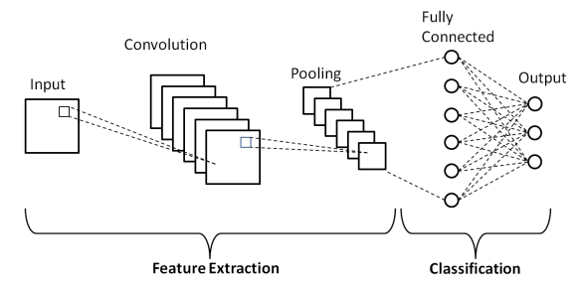

### *Fig.1 Basic CNN architecture*

From Fig. 1, the input, which we will treat as picture pixels like features, is sent to Convolution layer, which will then assemble the valuable features from the image before being sent to Pooling layer. With the necessary features, the pooling layer can reduce the image size. A completely linked layer will then execute the picture classification, returning a high percentage of the categorization. The CNN model will be categorized into four layers. They are:

**Convolution Layer:**

The Convolution layer is the initial layer of CNN and will be deployed to the screens to extract the picture features and conducting the linear transformation (dot product), this layer will be employed numerous filters. Here it can consider the images as spatial domain with matrix structure.

**ReLU Layer:**

After fulfillment of cnn model extraction, then it will be transmitted to rectified linear unit (ReLU) layer. All negative pixels will be replaced with 0 in this layer. It can return the rectified feature map by completing the element-wise process.

**Pooling Layer:**

The output of the ReLU layer feature map can be transferred to the pooling layer to obtain a pooled feature map, which will minimize the dimensionality of the feature map.

**Fully connected layer:**

All two-dimensional arrays will be transformed into one-dimensional long continuous linear vectors by this layer. Flattening is the name of this technique. The largest proportion of similarity in picture classification may come from this layer.

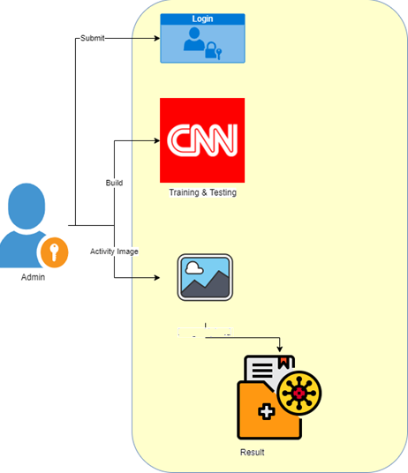

*Fig: - 2 System architecture*

Many traffic accidents are occurring everywhere these days as a result of driver inattention. Sometimes, drivers would operate their vehicles for extended periods of time without stopping, leaving them feeling fatigued and increasing the likelihood of traffic accidents. Here, there is no warning system to warn drivers who are driving while they are drowsy. Therefore, we are presenting Detection of Driver Drowsiness using Convolutional Neural Networks, a novel automatic alerting method. In this system, if a driver closes their eyes for an extended period of time, our application can generate an alarm to warn them. Similarly, if a driver yawns for an extended period of time, this system can also generate an alarm. This system helps to reduce accidents on the road by alerting drivers who are feeling sleepy and making them take action to prevent accidents or save their lives. We are obtaining the drowsiness-dataset from the Kaggle web repository in order to train the CNN model file. The four directories eye closed, eye open, yawn, and no yawn in this drowsiness-dataset each contain a number of sample photos.

4 classify of drowsiness like Closed, Open, no_yawn & yawn *dataset*

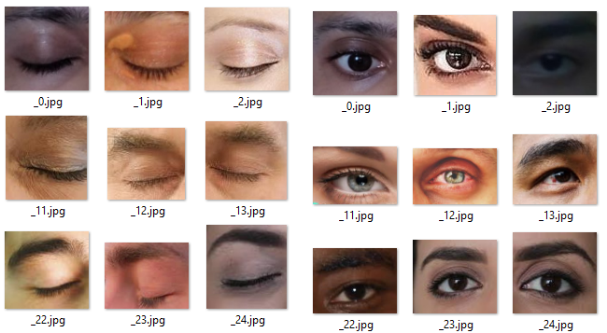

*Fig: -3 Eye Closed & Open dataset*

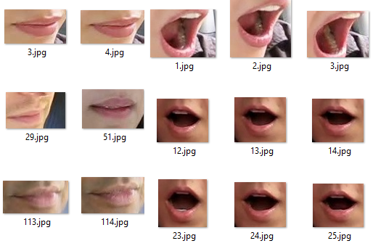

*Fig: - 4 no_yawn & yawn dataset*

1. **EXPERIMENTAL RESULT**

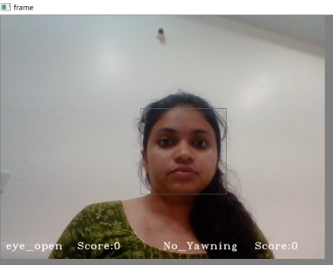

*Fig: - 5 Face Detection screen & score calculation*

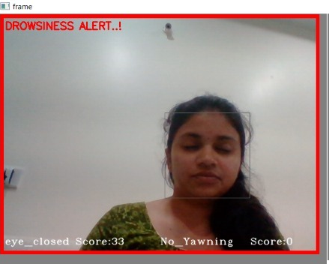

*Fig: - 6 Drowsiness alert based on Eye Closed score calculation*

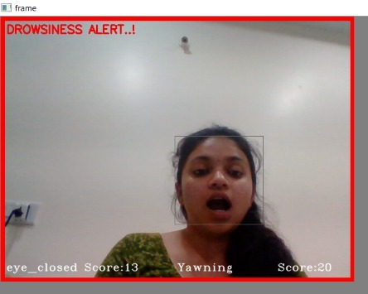

*Fig: - 7 Drowsiness alert based on Yawning score calculation*

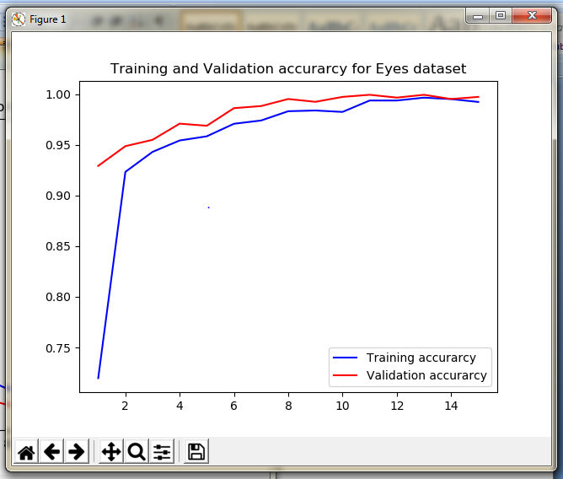

*Fig: - 8 Training accuracy on Eye Dataset*

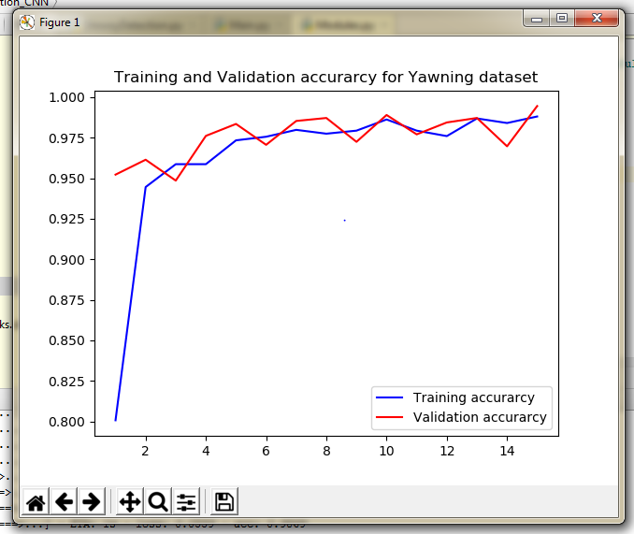

*Fig: - 9 Training accuracy on Yawning Dataset*

1. **CONCLUSION**

We developed a tool that may be used to detect drowsiness in this situation. Based on the image that is collected, a neural network determines whether the driver is awake or sleepy. Our testing findings demonstrate that this system model recognised sleepiness with 98 percent accuracy. The convolutional neural network (CNN) diverse subjects, there is a great potential of algorithm improvement by obtaining dataset vider in its diversity.

1. **REFERENCES**

[1] J. Ciganek and J. Osusky, “Structure Optimization of Artificial Neural Networks Using Pruning Methods”, IEEE Int. conf. Cybernetics & Informatics 2018, Lazy pod Makytou, Slovak Republic, 2018.

[2] A. Krizhevsky, I. Sutskever and G. E. Hinton, “ImageNet Classification with Deep Convolutional Neural Networks”, Advances In Neural Information Processing Systems, pp. 1-9, 2012.

[3] Z. Kepesiova, D. Rosinova and S. Kozak, “Comparison of Optimization Techniques for Process Recognition Using Deep Neural Network”, IEEE Int. conf. Advanced Control Circuits and Systems (ACCS’019) and New Paradigms in Electronics & information Technology (peit'019), Hurghada, EGYPT, 2019

[4] TensorFlow, [Online]. Available: <https://www.tensorflow.org/>. [Accessed Nov.9, 2019]

[5] “Home - Keras Documentation” keras.io, [Online]. Available: https://keras.io/. [Accessed Nov.9, 2019]

[6] G. Huang, Z. Liu, K. Q. Weinberger, and L. van der Maaten, “Densely connected convolutional networks,” in Proc. IEEE Conf. Comp. Vis. Patt. Recogn., pp. 4700–4708, 2017.

[7] He, K.; Zhang, X.; Ren, S.; and Sun, J. “Deep residual learning for image recognition”, In Proceedings of the IEEE Conference on Computer Vision and Pattern Recognition, 770–778, 2016

[8] C. Szegedy, V. Vanhoucke, S. Ioffe, J. Shlens, and Z. Wojna. “Rethinking the inception architecture for computer vision,. In IEEE CVPR, pages 2818–2826, 2016.